**Muster Point**

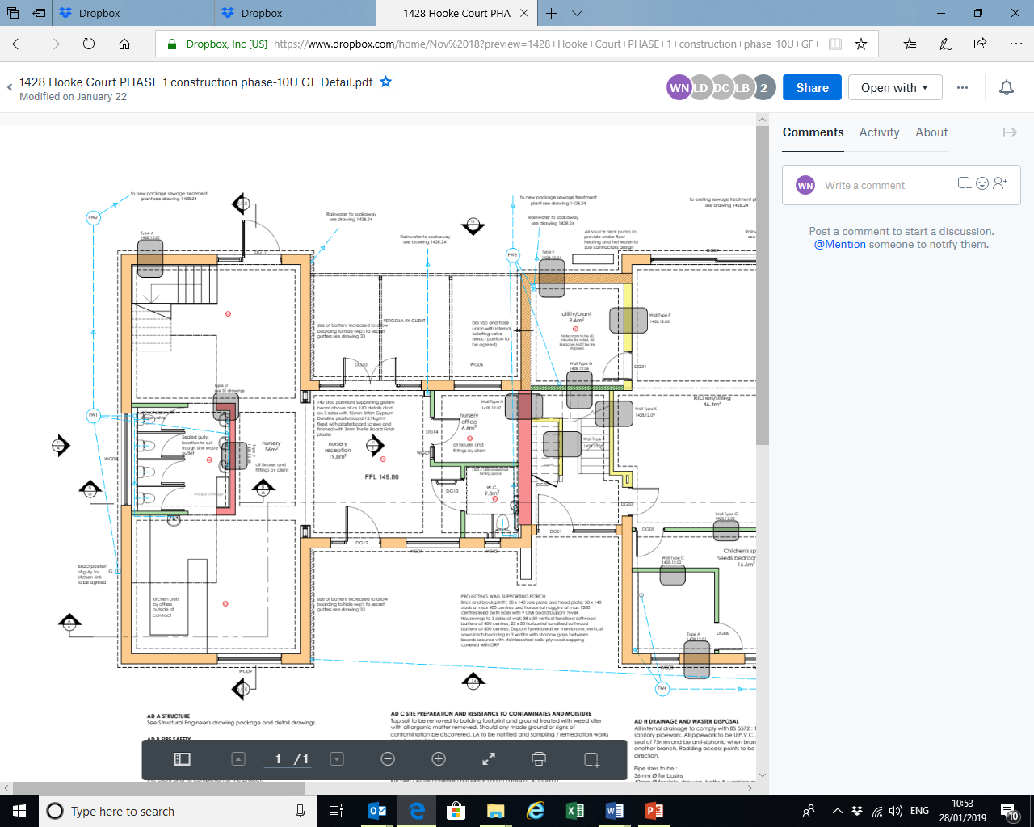

**Emergency Exit**

**Emergency Exitt**

**Emergency Exit**